
Online Typing Master

(Session 2020-2024)
By

AMEER HAMZA BSSIT-20-60
MUHAMMAD NAVEED BSSIT-20-58



Govt. Graduate College, Sahiwal Affiliated with BZU, Multan Pakistan

Online Typing Master
Session (2020-2024)

Submitted By

AMEER HAMZA BSSIT-20-60
MUHAMMAD NAVEED BSSIT-20-58
Project Supervisor
Mr. Waqas Ali


Department of Computer Science Govt. Graduate College, Sahiwal

Final Approval

Online Typing Master

The Documentation is submitted to the department of Computer Science, Govt. Graduate College, Sahiwal affiliated with Baha Uddin Zakariya University, Multan for the partial fulfillment of the requirement for the BS Information Technology (4 years).

Approved on:
By:

AMEER HAMZA BSSIT -20-60
MUHAMMAD NAVEED BSSIT-20-58

Internal Examiner External Examiner
Signature: Signature:

Mr. Waqas Ali Name:
Assistant Professor Organization & Designation:

Head of CS Department
Signature:

Muhammad Sajjad
Assistant Professor
Govt. Graduate College, Sahiwal.

Dedication
“Dedication is a devotion to which we love, who our benefactors are, who pray for us and who made us capable of doing all these, under this head; they are my PARENTS and our TEACHERS. So, we have devoted this report to our beloved and kind parents and teachers.”

PREFACE

It is the requirement of the BSIT course in Government Postgraduate College, Sahiwal Affiliated with BZU, MULTAN, that all students of Information Technology have to send software to complete his/her degree program.

After making different types of projects with help of different software, students would be able to work any software house or work as developer of any company. This would make a person more confident, more knowledgeable, and more responsible. It has enabled me to understand the practical scenario and how an organization converts his manual system into computerized system.
In preparing of this Final Project, we have put all of our best efforts and tried our level best to get maximum knowledge of programming and programming concepts.
Despite of our all the coherent efforts, we do believe that there will always be a room for improvement in the efforts of learner like us.

AMEER HAMZA BSSIT-20-60
MUHAMMAD NAVEED BSSIT-20-58

EXORDIUM
In the name of Allah, the Compassionate, the Merciful, Praise be to Allah, Lord of Creation,
The Compassionate, the Merciful, King of Judgment – day!
You are alone for worship, and to you alone we pray for help, Guide us to the straight path,
The path of those who you have favored, Not of those who have incurred your wrath, Nor of those who have gone astray.

Acknowledgment
With the blessings of Almighty Allah and the prayers of our parents, we have made this attempt to achieve the goal that was set for us to complete the BS degree. Although the project was complex and complicated, we put our maximum effort to fulfill the goal. We would like to express our deepest appreciation to all those who provided us with the possibility to complete this report. A special gratitude we give to our final year project supervisor, Mr. Waqas Ali, whose contribution in stimulating suggestions and encouragement, helped me to coordinate my project especially in writing this report.
Furthermore, I would also like to acknowledge with much appreciation the crucial role of the staff of the Information Technology Department of GGCS, who permitted to use all required equipment and the necessary material to complete the task. Last but not least, many thanks go to the head of the department, Muhammad Sajjad who has invested his full effort in guiding me to achieve the goal. I have to appreciate the guidance given by other supervisors as well as panels, especially in our project presentation that has improved our presentation skills thanks to their comments and advice.

AMEER HAMZA BSSIT-20-60
MUHAMMAD NAVEED BSSIT-20-58

Abstract
The Online Typing Master is a comprehensive web-based application designed to enhance users' typing skills through structured practice sessions, timed tests, and competitive typing challenges. This platform promotes interactive learning and provides an engaging environment for users of all levels, from beginners to advanced typists.
The system offers a user-friendly interface where users can access various modules such as Practice Mode, Typing Tests, and Typing Competitions. In Practice Mode, users can improve their speed and accuracy with customizable exercises. The Typing Test module allows users to evaluate their typing performance under time constraints, generating detailed reports including words per minute (WPM), accuracy, and error analysis. In the Competition Module, users can participate in real-time typing contests with others, encouraging healthy competition and skill improvement.
A key feature of the Online Typing Master is its performance tracking capability, which stores users’ progress and test results for future review. This enables users to monitor improvements over time and target areas where they need to enhance their skills. The platform also includes interactive leaderboards, personalized progress charts, and motivational badges to keep users engaged.
Security and data integrity are upheld through secure user authentication and encrypted data storage. Additionally, the system is designed to be responsive and accessible across various devices, ensuring flexibility for users to practice anytime, anywhere.
Overall, the Online Typing Master is a powerful and engaging solution that supports users in building and mastering their typing abilities through structured learning, competitive interaction, and continuous progress tracking.

List of Abbreviations
PHP Hypertext Preprocessor
MVC Model View Controller
CRUD Create, Read, Update, Delete
ORM Object Relational Mapping
JWT JSON Web Token
SQL Structured Query Language
HTML Hypertext Markup Language
CSS Cascading Style Sheets
JS JavaScript
JSON JavaScript Object Notation
CI/CD Continuous Integration/Continuous Deployment
IDE Integrated Development Environment
CLI Command Line Interface
URL Uniform Resource Locator
SSL Secure Sockets Layer
HTTP Hypertext Transfer Protocol
HTTPS Hypertext Transfer Protocol Secure
DNS Domain Name System
CRON Cron job scheduler
DB Database
UI User Interface
UX User Experience
JWT JSON Web Token
ACL Access Control List
GUI Graphical User Interface
SaaS Software as a Service
PaaS Platform as a Service
IaaS Infrastructure as a Service
CI Continuous Integration

Table of Contents

Preliminary Pages
- Title Page ...................................................................................................................................... [Page 1]
- Approval Sheet ............................................................................................................................. [Page 2]
- Dedication .................................................................................................................................... [Page 3]
- Preface ............................................................................................................................................. [Page 4]
- Exordium ..................................................................................................................................... [Page 5]
- Acknowledgment ..................................................................................................................... [Page 6]
- Abstract ....................................................................................................................................... [Page 7]
- List of Abbreviations ................................................................................................................. [Page 8]

Chapter 1: Introduction
1.1 Introduction ............................................................................................................................... [Page 9]
1.2 Objectives .................................................................................................................................. [Page 9]
1.3 Existing System ...................................................................................................................... [Page 10]
1.4 Problem Statement ............................................................................................................. [Page 10]
1.5 Proposed System ................................................................................................................ [Page 11]
1.6 Scope of Project .................................................................................................................... [Page 12]

Chapter 2: Analysis
2.1 Feasibility Study ...................................................................................................................... [Page 13]
2.1.1 Technical Feasibility ...................................................................................................... [Page 13]
2.1.2 Economic Feasibility ..................................................................................................... [Page 14]
2.1.3 Operational Feasibility ............................................................................................... [Page 14]
2.2 User Requirements ............................................................................................................. [Page 15]
2.2.1 Functional Requirements .......................................................................................... [Page 15]
2.2.2 Non-Functional Requirements ................................................................................ [Page 16]
2.3 System Requirements .......................................................................................................... [Page 17]
2.3.1 Hardware Requirements ............................................................................................ [Page 17]
2.3.2 Software Requirements ............................................................................................. [Page 18]
2.4 Use Case Overview ............................................................................................................... [Page 19]

Chapter 3: System Design
3.1 Architectural Design ............................................................................................................. [Page 20]
3.1.1 Purpose & Components ............................................................................................ [Page 21]
3.2 Software Design ................................................................................................................... [Page 22]
3.2.1 Class Diagram ............................................................................................................... [Page 23]
3.2.2 Activity Diagram ............................................................................................................ [Page 24]
3.2.3 Sequence Diagram ....................................................................................................... [Page 25]

Chapter 4: Database Design
4.1 Introduction ............................................................................................................................ [Page 26]
4.2 ER Diagram .............................................................................................................................. [Page 27]
4.3 Database Tables ..................................................................................................................... [Page 28]
4.3.1 user Table ...................................................................................................................... [Page 29]
4.3.2 test Table ................................................................................................................................. [Page 30]
4.3.3 competitions Table ................................................................................................................ [Page 31]
4.3.4 results Table ........................................................................................................................... [Page 32]

Chapter 5: System Implementation
5.1 Introduction ............................................................................................................................. [Page 33]
5.2 Technologies Used ............................................................................................................... [Page 34]
5.3 System Architecture ............................................................................................................ [Page 35]
5.4 Module Implementation ................................................................................................... [Page 36]
5.4.1 User Registration .......................................................................................................... [Page 37]
5.4.2 Typing Practice Module .............................................................................................. [Page 38]
5.4.3 Competition Module ................................................................................................... [Page 39]
5.4.4 Results Display .............................................................................................................. [Page 40]
5.5 Screenshots .................................................................................................................... [Pages 41-44]

Conclusion & Future Work
Conclusion .......................................................................................................................................... [Page 45]
Future Work .............................................................................................................................. [Pages 46-48]

Chapter #1 Introduction

1.1 Introduction
We propose an "Online Typing Master" system—a fully functional web-based application aimed at improving and managing users' typing performance through various interactive modules such as practice sessions, typing tests, and real-time competitions. This platform assists users in enhancing their typing speed and accuracy while also allowing administrators to manage content, performance data, and user rankings efficiently.
The system enables users to register, select practice modules, take speed tests, and engage in competitive typing battles with other users. Each test session's results, such as words per minute (WPM), accuracy, and error rate, are stored in the system's database. Users can later log in to review their performance history and track improvements over time. Administrators can manage user accounts, configure typing exercises, and oversee competitive events.
This online solution eliminates the need for offline software installations and manual performance tracking. It provides an intuitive, centralized interface to handle user progress and interaction effectively through a desktop or web environment.

1.2 Objectives
The objectives of this project are as follows:
- To reduce manual tracking and paperwork related to typing practice and tests.
- To improve accuracy and organization in user performance records.
- To enable administrators to access any user's progress and history with just a few clicks.
- To maintain detailed records of typing performance without physical paperwork.
- To minimize redundancy in test data.
- To secure and protect user data.
- To enhance consistency in tracking and evaluation.
- To support online test scheduling and competition participation.
- To allow users to provide feedback on tests and features.

1.3 Existing System
In existing typing improvement systems, many users rely on basic offline software or manual methods to assess their typing capabilities. Tracking test performance often involves note-taking or screenshots, which is both time-consuming and prone to errors. Typing records and user progress are not maintained in a structured way, and competitive interaction between users is almost non-existent.
Manual record-keeping makes it difficult to store and retrieve progress details, increasing the chances of inaccuracy and data loss. These outdated methods are inefficient, require extra effort, and fail to provide a motivating or interactive learning environment.

1.4 Problem Statement
Upon examining traditional typing practice systems, several issues have been identified:
- Manual methods lack an efficient management interface for test and practice modules.
- Offline systems do not store or track historical data effectively.
- High risk of data loss, unauthorized access, and inconsistency in performance metrics.
- Current systems often suffer from slow performance and limited engagement features.
- It is difficult for users to compare their performance or compete with others.
- Managing typing exercises, scores, and user profiles manually is time-consuming.
- There is no centralized platform to analyze progress, manage competitions, or handle user data securely.

1.5 Proposed System
The proposed Online Typing Master system is a completely web-based and automated solution. It streamlines performance tracking, reduces manual effort, and provides a highly interactive interface for both practice and competition.
Key improvements include:
- Users can easily select modules such as Practice Mode, Speed Tests, or Competitions.
- All test results are automatically stored, analyzed, and presented in charts or reports.
- Admins can manage typing challenges, review user performance, and monitor system-wide activity through a dashboard.
- Each user’s typing history is accessible upon login, improving learning and review.
- Secure role-based access allows different privileges for users and administrators.
- The system is responsive and accessible across devices.
Overall, this system boosts engagement, encourages skill development, and eliminates traditional barriers to typing proficiency.
1.6 Scope of Project
The scope of this system defines the range of its functionalities and how it integrates into users’ digital learning routines. As digital literacy and typing proficiency become essential in today's world, this platform supports users in developing one of the most fundamental skills in computing—typing.
Given the rise in online education and competitive learning, this project has a broad reach. It is compatible with modern devices, making it accessible to students, professionals, and hobbyists alike.
Key Features:
- User-friendly interface
- Practice, Test, and Competition modules
- Automatic performance tracking
- Real-time leaderboards
- Responsive design for mobile and desktop
- Minimal paperwork or manual handling
- Encourages consistent improvement and motivation

Chapter #2

Analysis

2.1 Feasibility Study
A feasibility study is conducted soon after defining the problem to assess whether the objectives of the Online Typing Master project are realistically achievable within time, budget, and technical constraints. It identifies potential areas where savings in time, effort, and cost can be made and helps the system analyst devise an effective strategy for implementation. This study also outlines data flow, necessary processing, expected outputs, and any constraints on the system.

The following types of feasibility analyses were performed:
- Technical Feasibility
- Economic Feasibility
- Operational Feasibility

2.1.1 Technical Feasibility

The Online Typing Master system is technically feasible, as it is built using secure, reliable, and widely adopted technologies. The stack includes HTML5, CSS, JavaScript, PHP (Laravel), Bootstrap, and MySQL. These tools support the required performance, responsiveness, and data handling needed for real-time competitions, user tracking, and graph generation. The system runs on standard web servers and is compatible with all modern browsers and devices.

2.1.2 Economic Feasibility

This project is economically viable due to its use of free and open-source tools, reducing the cost of development. An estimated 25-30% of expenses are saved by utilizing existing infrastructure. The human and computing resources required are minimal and cost-effective. Once deployed, the system will further reduce costs by automating test evaluations, result tracking, and performance analysis.

2.1.3 Operational Feasibility

Operationally, the system is designed to meet user needs and simplify the typing learning process. It offers features like timed tests, real-time competitions, and progress tracking through graphs. These functionalities address current gaps in manual or basic typing practice systems. The platform enhances user engagement while ensuring accuracy, security, and ease of use.
The Online Typing Master is built to eliminate inefficiencies, provide instant feedback, and create a more motivating learning experience for users of all levels.

2.2 User Requirements and Specification

This section outlines what users expect from the system in terms of functionality and performance.

2.2.1 Functional Requirements
Admin
- Login
- Add/Edit/Delete Practice Modules
- Create and manage Typing Tests
- Organize and schedule Online Competitions
- View user performance reports and graphs
- Manage user accounts and roles
- Monitor leaderboard and feedback
User (Learner/Participant)
- Sign up/Login
- Access Practice Mode (custom lessons, difficulty levels)
- Attempt Typing Tests (timed, graded)
- View personal performance graph (WPM, accuracy, error rate)
- Participate in real-time typing competitions
- View leaderboard and rankings
- Submit feedback or report issues
2.2.2 Non-Functional Requirements

The system is expected to meet the following non-functional requirements:
- Security – User data and performance results are protected
- Efficiency – Fast data retrieval and performance analytics
- Effectiveness – High usability and accuracy in test results
- Accessibility – Usable across devices (desktop, tablet, mobile)
- Scalability – Supports a growing number of users and modules
- Reliability – Minimal system failures, high uptime
- Maintainability – Easy updates and bug fixing
- Usability – Clean, intuitive UI for learners and admins
- Multitasking – Multiple users can perform tests simultaneously
- Graphical Reporting – Visual analysis of typing speed and errors

2.3 System Requirements

These requirements specify the hardware and software prerequisites for developing and running the Online Typing Master system.

2.3.1 Hardware Requirements

- Processor: Intel Pentium or higher
- RAM: 512 MB (1 GB or higher recommended)
- Cache Memory: 512 KB or more
- Hard Disk: Minimum 10 GB free space
- Monitor: 15" or larger, resolution 1024x768 or higher
- Input: Standard Keyboard and Mouse

2.3.2 Software Requirements

- Operating System: Windows 10 or higher
- Languages & Technologies: HTML5, CSS3, JavaScript, PHP (Laravel Framework)
- Database: MySQL
- IDE: Visual Studio Code or Sublime Text
- Web Server: Apache (via WAMP/XAMPP)
- Browsers: Google Chrome, Mozilla Firefox, Microsoft Edge
- Documentation: Microsoft Word 2010 or higher
- Analytics/Graphing Library: Chart.js or similar

2.4 Use Case Overview

A Use Case diagram illustrates the interactions between users (actors) and the system to achieve specific goals. It helps in identifying, organizing, and documenting system requirements.
Actors
- Admin – Manages system modules, users, and competitions
- User – Interacts with the system to practice, take tests, and compete
Use Cases
- Admin adds/updates practice content
- Admin schedules competitions
- Admin views system-wide statistics
- User takes a typing test
- User views result in graph
- User joins competition
- System updates leaderboard
Use Case Diagram Components
- System Boundary: Defines what is inside/outside the scope
- Actors: Admin, User
- Use Cases: Actions like Login, Take Test, View Graph, Compete
- Relationships: Connection lines between actors and use cases
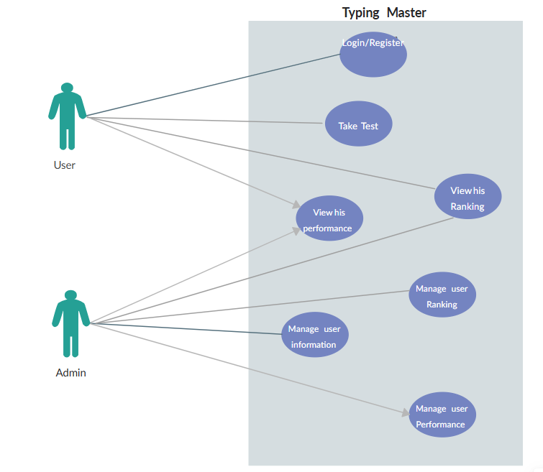

Use Case ID | Use Case Name | Description | Input(s) | Output(s)
UC-01 | User Registration | User signs up with personal details. | Name, Email, Password | Success/Error message, account created
UC-02 | User Login | Logs into the system with credentials. | Email/Username, Password | Redirect to dashboard or show login error
UC-03 | Start Practice | Allows user to select and begin a typing practice session. | Difficulty level, Lesson type | Typing area with lesson content, timer
UC-04 | Submit Practice Result | Automatically evaluates practice session. | Typing input, Time taken | Accuracy, WPM, Mistakes, Time
UC-05 | Take Typing Test | Start a formal test session. | Test ID, Timer start | Real-time feedback, Result at end of test
UC-06 | Submit Test Result | System calculates and stores result data. | Typed input | Result (WPM, Accuracy), Stored in DB
UC-07 | View Result in Graph | Shows visual graph of user’s typing performance over time. | User ID | Line/bar chart of past performance
UC-08 | Join Competition | Allows user to join a real-time typing competition. | Competition Code or Open Event | Competition environment with timer
UC-09 | Submit Competition Result | Evaluates and ranks competition results. | Typing input, Timer | Final score, Rank, Competition summary
UC-10 | View Leaderboard | Displays top performers globally or within session. | N/A | Leaderboard (Top WPM/Accuracy)
UC-11 | Submit Feedback | User gives feedback or reports issues. | Feedback text, Rating | Feedback saved, Acknowledgement message
UC-12 | Manage Users | View, block, or delete user accounts. | User list action | Success message or error
UC-13 | Manage Lessons/Tests | Create, edit, delete practice lessons or test data. | Lesson text, time, difficulty | Stored or updated content
UC-14 | Schedule Competitions | Create a future or live typing competition. | Title, Date, Duration, Participants | Event created, visible to users
UC-15 | Monitor User Progress | View detailed performance reports for individual users. | User selection | Graphs or tabular data of typing stats
UC-16 | Export Reports | Export performance data in PDF/CSV format. | Date range, User selection | Downloadable file

Chapter #3

System Design

3.1 System Architectural Design
System architecture refers to the conceptual model that defines the structure, behavior, and essential components of a software system. For the Online Typing Master (OTM) platform, the system architecture is designed to ensure modularity, performance, user-friendliness, and scalability. It organizes the system's hardware and software elements and defines how they interact to achieve the application's objectives.

3.1.1 Architectural Purpose in OTM
The architecture of OTM supports:
- User role differentiation: Admin and general users (typists).
- Modular segregation: Practice, test, result tracking, and online competition modules operate as distinct, yet connected parts of the application.
- Real-time processing: Tracks live typing speed (WPM), accuracy, and mistakes.
- Secure storage and retrieval: All performance data and user interactions are stored securely in a structured relational database.
- Live competition and leaderboard logic: Enables multiple users to participate in real-time typing contests with scoring and ranking features.

3.1.2 System Components
Component | Role in OTM
Frontend (UI) | Provides user interfaces for login, practice, tests, competitions, and results.
Backend (API + Logic) | Handles core logic, scoring algorithms, authentication, and session handling.
Database | Stores user accounts, practice/test data, competition results, feedback, etc.
Admin Panel | Allows admin to manage users, view reports, configure tests/competitions.
Real-time Engine | Manages online competition logic and live leaderboard updates.
Example Technologies:
- Frontend: HTML5, CSS3, JavaScript, Bootstrap
- Backend: PHP (Laravel Framework)
- Database: MySQL
- Server: Apache/WAMP or Live Hosting
- Real-time Features: AJAX/WebSockets for competitions

Figure 3.1 – System Architecture Diagram
(Illustrate flow between frontend, backend, modules, and database here.)

3.2 System Software Design
Software design is the blueprint that guides how the components of the system are implemented and interact. It ensures that the system is:
- Structured logically.
- Easy to maintain.
- Scalable for future upgrades.
OTM’s software design consists of object-oriented models and dynamic flow representations using UML diagrams.

3.2.1 Class Diagram
A Class Diagram is used to describe the static structure of a system by showing system classes, attributes, operations, and relationships.
Main Classes in OTM
Class Name | Attributes | Methods
User | id, name, email, password, role | login(), logout(), joinCompetition(), viewPerformance(), editProfile()
Admin | adminId, username, password | createTest(), manageUsers(), createCompetition(), viewReports()
PracticeSession | sessionId, userId, paragraph, accuracy, wpm, errors | startSession(), stopSession(), calculateResults()
TypingTest | testId, difficulty, paragraph, timeLimit | beginTest(), submitTest(), evaluatePerformance()
Result | resultId, userId, wpm, accuracy, dateTime | displayGraph(), exportReport(), filterResults()
Competition | compId, title, participants[], winnerId | createComp(), registerUser(), evaluateComp(), announceWinner()
Feedback | feedbackId, userId, content, rating, dateSubmitted | submitFeedback(), deleteFeedback(), viewFeedback()
Class diagram helps in understanding object interactions and designing databases accordingly.

3.2.2 Activity Diagram
Activity Diagrams are used to model the flow of control or data from one activity to another in the system. They visually show the sequence of actions and decision points.

Admin Activity Diagram
Purpose: Shows the steps followed by the admin to manage users and content.
Step | Activity
1 | Admin logs into the system
2 | Navigates to Dashboard
3 | Manages Users (add/delete/update)
4 | Creates or updates typing tests
5 | Views real-time results & feedback
6 | Schedules or runs online competitions
7 | Logs out

User Activity Diagram
Purpose: Represents actions by the general user (typist) while using the system.
Step | - Activity
1 | User registers and logs in
2 | Selects Practice or Test module
3 | Starts typing session
4 | Views real-time WPM and accuracy
5 | Submits session/test
6 | Views detailed results
7 | Joins competition or gives feedback
8 | Logs out

- Practice Activity Diagram
Flow
User → Select Difficulty → Load Paragraph → Start Typing → Track Accuracy & Speed → End Session → Save and Show Summary

- Test Activity Diagram
Flow
User → Select Test Level → Start Timer → Type Paragraph → Submit → Evaluate WPM & Errors → Show Final Result

- Competition Activity Diagram
Flow
Admin Creates Event → Users Register → Countdown Starts → Typing Begins → Real-Time Scoring → Winner Announced

3.2.3 Optional: Sequence Diagram (Can be included if desired)
Sequence Diagrams illustrate how processes operate with one another and in what order.
Example: Typing Test Submission
Actor | Action
User | Clicks "Start Test"
System | Loads paragraph and timer
User | Types and submits
System | Processes input and calculates result
Database | Stores result
System | Displays summary to user

3.2.3 Interaction Sequence Diagram
In software engineering, especially in modeling dynamic behavior, interaction diagrams play a vital role in representing how objects in a system interact over time to achieve a specific functionality. In the Online Typing Master (OTM), interaction diagrams are crucial for understanding the flow of messages between users and the system's core components, especially during critical activities like login, taking a typing test, and participating in competitions.
There are two types of interaction diagrams in UML:
- Sequence Diagram – Focuses on the time order of message exchanges.
- Collaboration Diagram – Focuses on the structural organization and links between the interacting objects.
For OTM, we use the Sequence Diagram to illustrate the time-based sequence of interactions between the system and its users (both typists and admins).

Purpose of Sequence Diagram
The sequence diagram is used to model:
- The dynamic behavior of the OTM system.
- The message flow during a specific user activity.
- The interaction between frontend users and backend objects/services.
- The order of events when an operation like taking a test or submitting results occurs.
These diagrams help developers and analysts to:
- Identify key processes in the user journey.
- Understand system reactions to user inputs.
- Debug or extend specific flows (e.g., live competition joining or result rendering).

Key Use Cases Modeled by Sequence Diagrams
Use Case | Description
User Login | Flow from login request to validation and session creation.
Typing Test Start & Submission | Full interaction of loading test, typing, submitting, and result calculation.
Result Visualization | Interaction from result request to displaying WPM, accuracy, and graph.
Competition Participation | Flow covering user registration, competition initiation, and winner result.
Admin Managing Tests | Sequence of admin actions to create or modify test content.

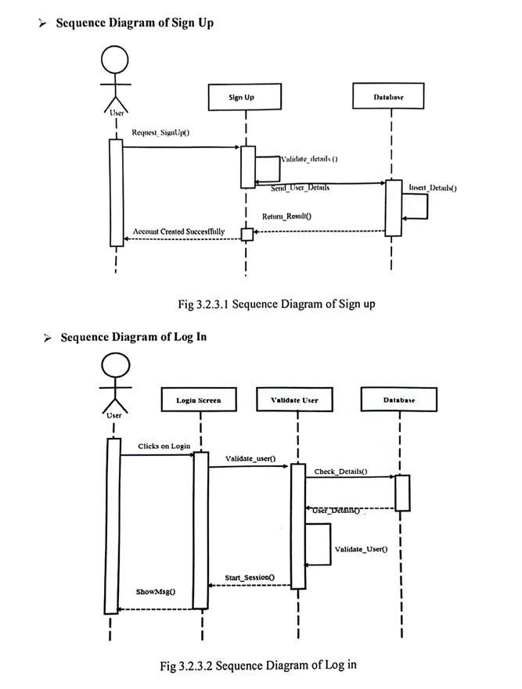

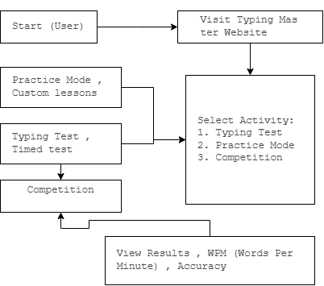

Chapter# 4
Database Design

4.1 Introduction
The database design forms the backbone of any data-driven application. For this project, a relational database was designed to efficiently store and retrieve data related to users, typing tests, scores, and competition history. MySQL was used as the database management system due to its performance and open-source support.

4.2 Entity-Relationship (ER) Diagram
The ERD combines both Typing Practice and Typing Competition modules into a unified data model. It helps in visualizing entities, their attributes, and relationships between them. (Insert the
ERD

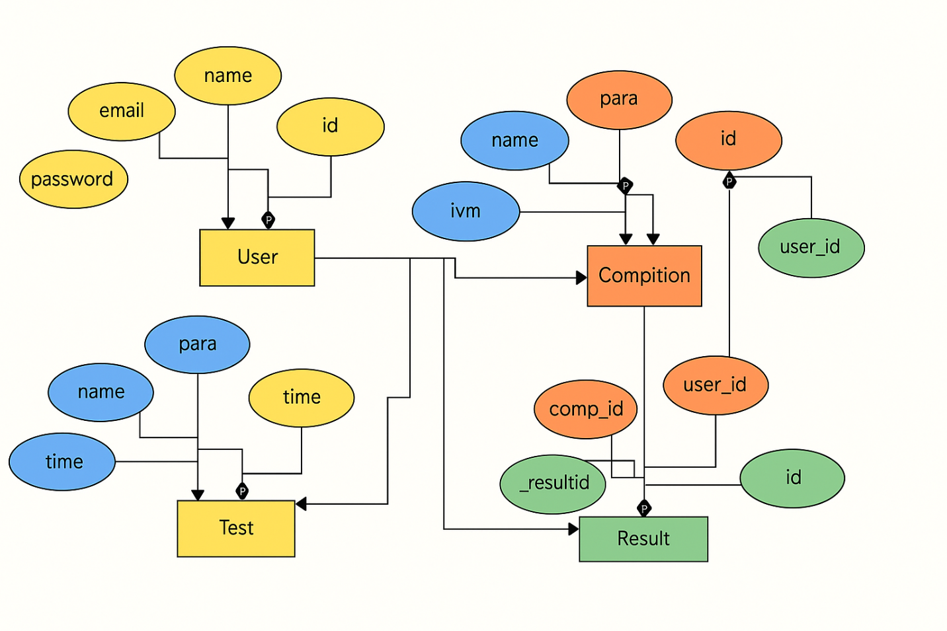

ERD

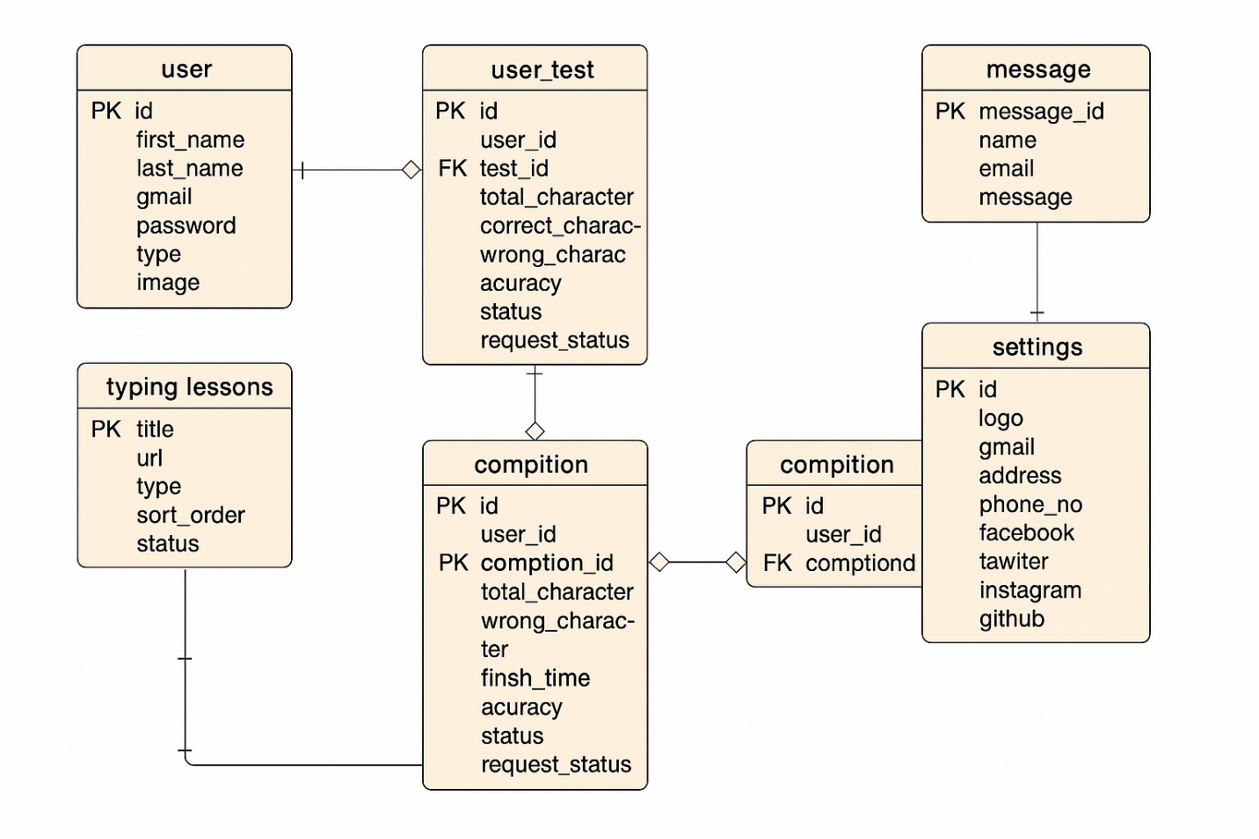

4.3 Database Tables Overview
The system uses four major entities:
- User
- Test
- Competition
- Result
Below is a description and SQL definition for each table.

4.3.1 “user”Table
Stores user registration and login details.

Field | Type | Description
id | INT (PK) | Unique user ID
name | VARCHAR(100) | User's full name
email | VARCHAR(100) | User's email address
password | VARCHAR(255) | Hashed password

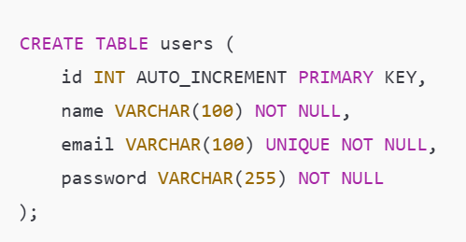

4.3.2 test Table
Stores paragraphs for typing tests created by admin or users.
Field | Type | Description
id | INT (PK) | Unique test ID
name | VARCHAR(100) | Title or topic of test
para | TEXT | Paragraph for typing
time | INT | Time allowed (seconds)
user_id | INT (FK) | Creator of the test

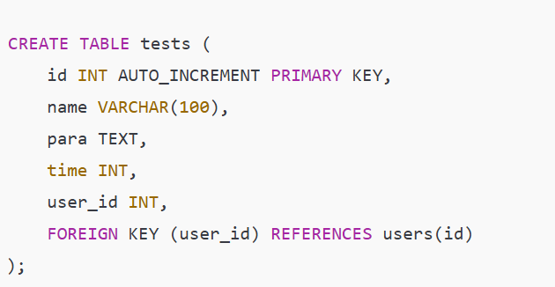

4.3.3 competitions Table
Contains typing competition records.
Field | Type | Description
id | INT (PK) | Unique competition ID
name | VARCHAR(100) | Title of competition
para | TEXT | Competition paragraph
time | INT | Time allowed (seconds)
user_id | INT (FK) | Creator (or admin) ID

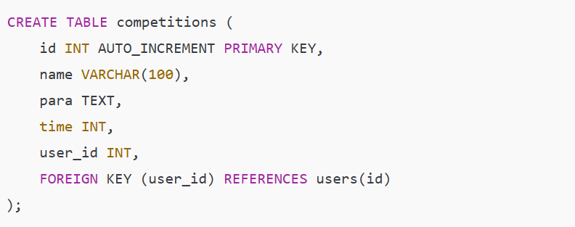

4.3.4 results Table
Stores performance records of users in competitions.
Field | Type | Description
id | INT (PK) | Unique result ID
resultid | VARCHAR(50) | System-generated result code
comp_id | INT (FK) | Competition this result belongs to
user_id | INT (FK) | Participant (user)

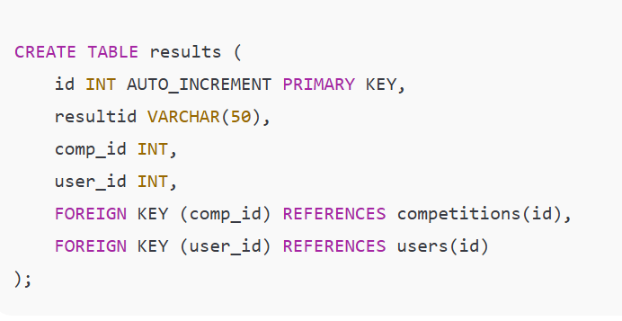

4.4 Relationships Summary
- A user can create many tests and competitions.
- A competition can have many results.
- Each result is linked to one user and one competition.

4.5 Notes on Implementation
- Password hashing is implemented using bcrypt() during registration.
- Indexes are added automatically on primary and foreign keys.
- The database is designed in MySQL.
- Data validation is performed both at frontend and backend (Laravel or C

Summary
This chapter explained the core structure of the database using ERD and SQL schema definitions. The logical and physical design ensures efficient data storage, scalability, and relationships among entities.

Chapter 5:
System Implementation

5.1 Introduction
The purpose of this chapter is to explain how the system was built practically. It discusses the technologies used, how each module was implemented (Test, Competition, Results), and how users interact with the system. Screenshots of key pages are included to demonstrate the user interface.

5.2 Technologies Used
Technology | Purpose
PHP (CodeIgniter 3) | Backend Framework
MySQL | Database
HTML, CSS, Bootstrap | Frontend Structure and Styling
JavaScript / jQuery | Form validation, AJAX
Stripe API (if used) | Card payments (optional)
WAMPP | Local development server

5.3 System Architecture
The system follows an MVC (Model-View-Controller) architecture using CodeIgniter 3:
- Model: Handles database queries.
- View: Displays the UI (HTML + Bootstrap).
- Controller: Processes logic and connects view with model.

5.4 Module Implementation

5.4.1 User Registration and Login
- User creates an account with name, email, and password.
- Passwords are hashed using PHP’s password_hash() function.
- On login, credentials are verified against the database.

5.4.2 Typing Practice Module (Test)
- User selects a paragraph to practice.
- Timer is displayed alongside text box.
- After typing, WPM (words per minute) and accuracy are shown.

5.4.3 Typing Competition Module
- Admin can create a new competition with a paragraph and timer.
- Users can join a competition and type within the given time.
- On completion, their results are stored.
Features:
- Live countdown
- Paragraph locking after time
- Result is stored in results table

5.4.4 Result Calculation and Display
- Each participant's result is saved with:
  - Competition ID
  - User ID
  - WPM
  - Accuracy
- Admin can view all participants for any competition.
5.5 Key Screenshots
• Registration & Login page
• Dashboard (after login)
• Typing Test Interface
• Competition Join Page
• Result Page
• Admin Panel

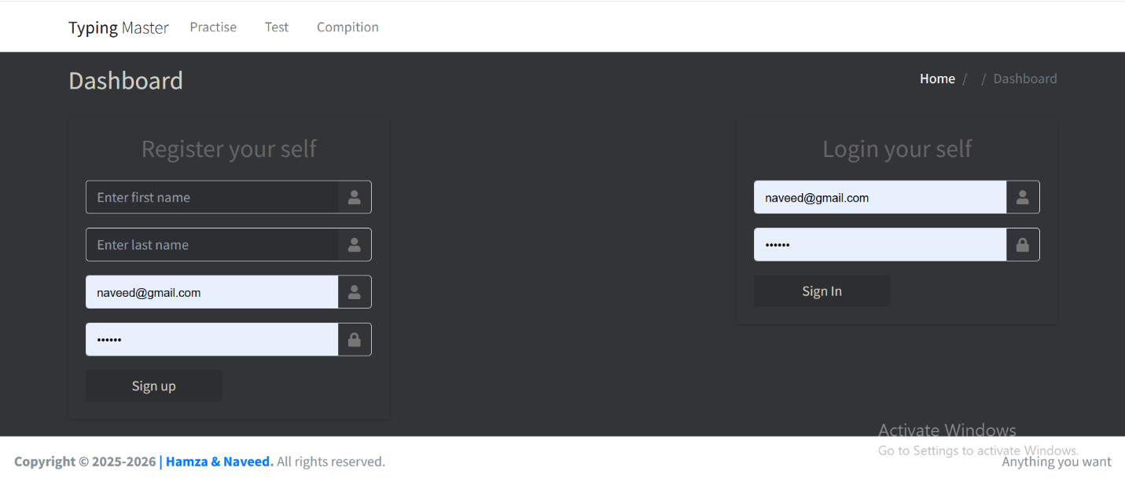
Registration & Login page
Dashboard (after login)
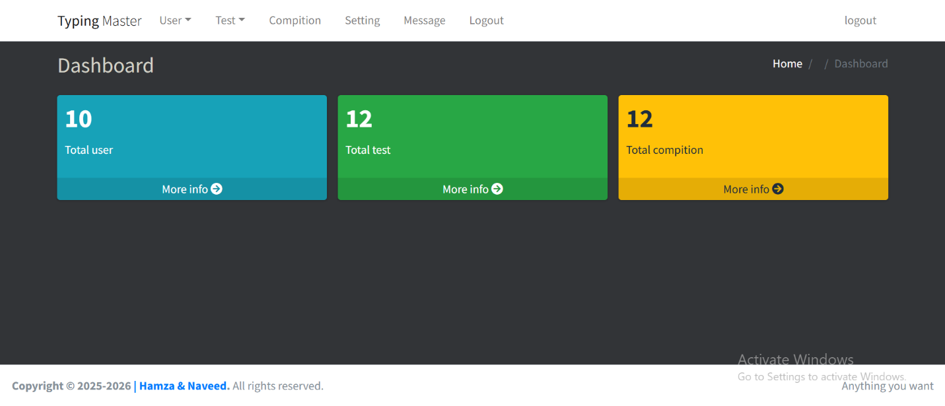

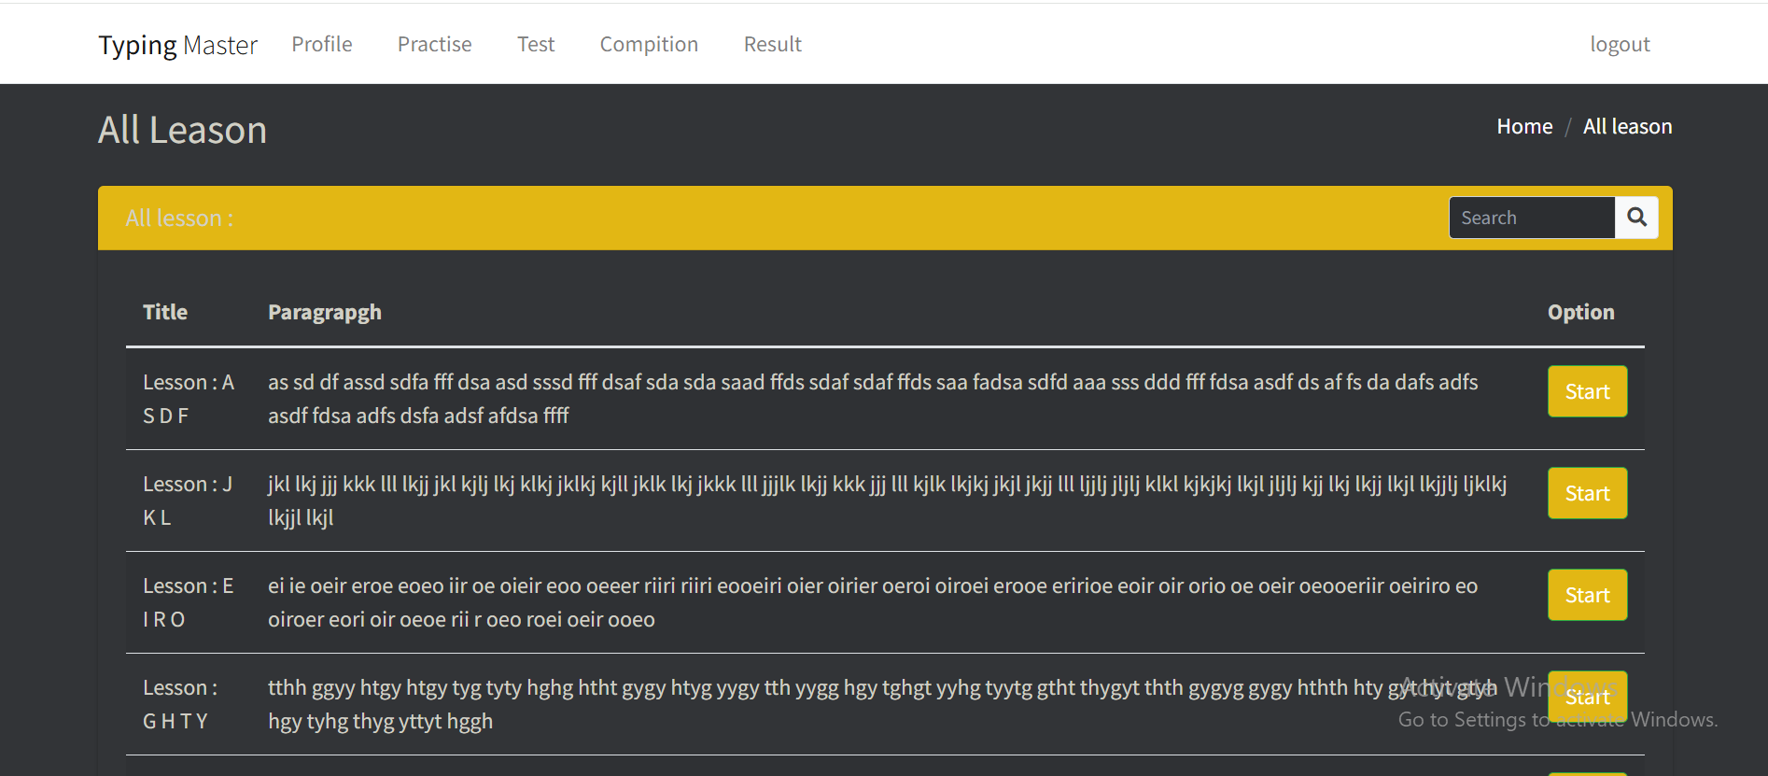
Typing Test Interface

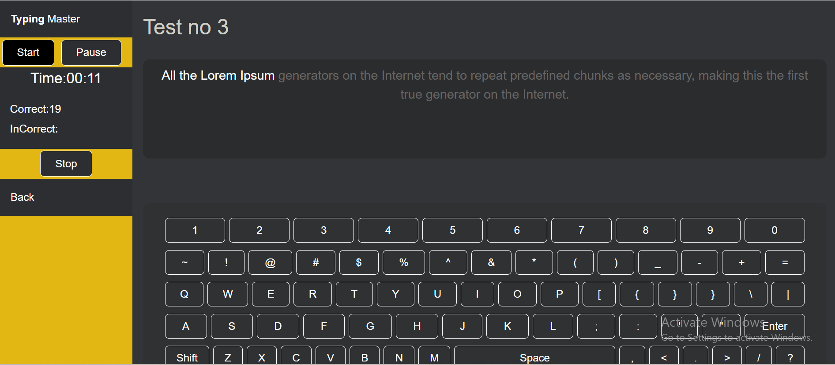

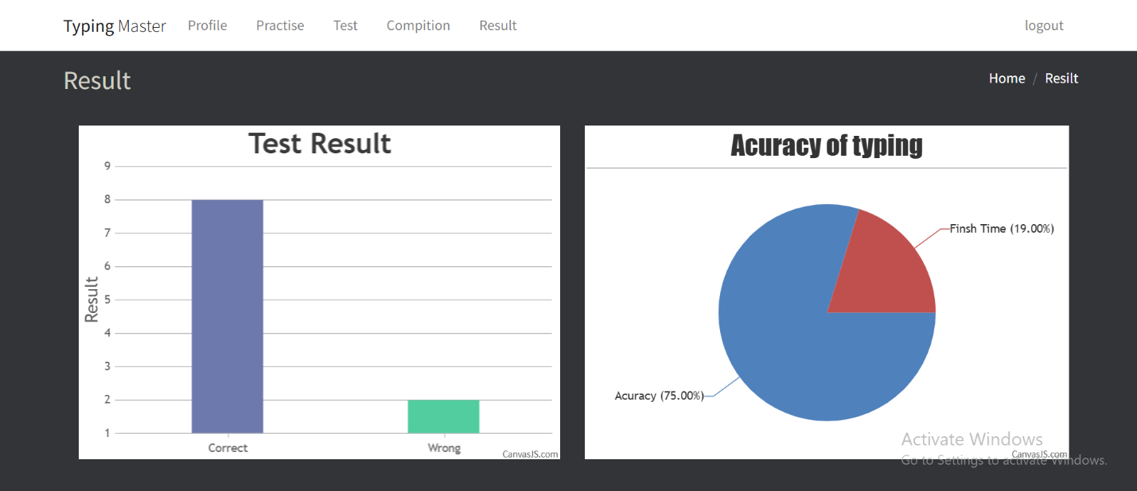
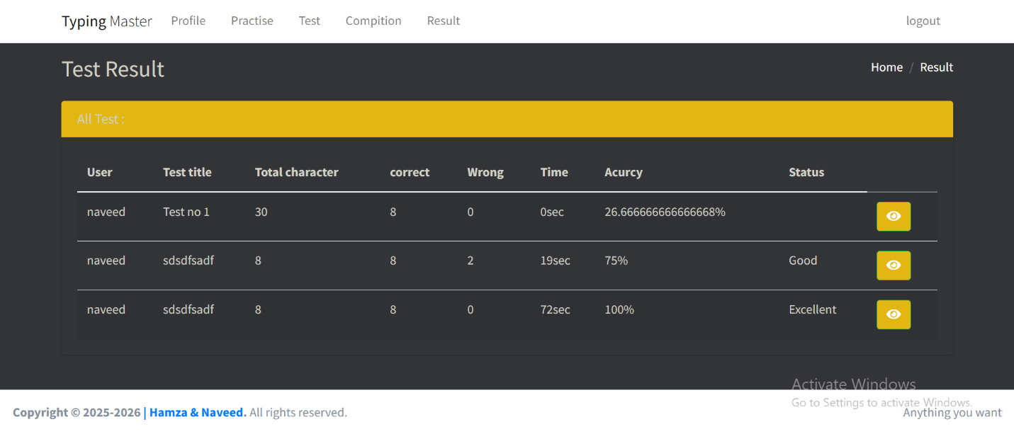

Conclusion &
Future Work

Conclusion:
The Online Typing Master (OTM) system represents a significant step forward in digital learning, offering a modern and interactive platform for users to enhance their typing skills. Through structured modules like Practice, Test, Results with Graphs, and Online Competitions, the system provides a complete learning environment that is both user-friendly and performance-driven.
By automating the process of tracking user progress and offering real-time feedback, OTM not only saves time but also motivates users through gamified competition and graphical performance analysis. This improves typing speed and accuracy while offering a convenient and accessible platform for learners of all ages. The system serves educational institutions, individuals, and training centers aiming to build or improve typing proficiency.

Future Work:
Although the current system effectively covers basic typing training and performance tracking, there are several directions in which Online Typing Master can be expanded and enhanced:
- Mobile Application Support:
Develop a dedicated mobile app version of OTM to allow users to practice typing and participate in competitions using their smartphones and tablets, making learning truly portable.
- Gamified Learning Experience:
Introduce interactive games and challenges that help users learn typing through fun-based methods, improving engagement and retention.
- Real-Time Competition System:
Enhance the competition module with real-time multiplayer features where users can challenge each other live and receive instant rankings and rewards.
- Integration of AI-Powered Feedback:
Implement AI-based suggestions to provide personalized improvement tips based on each user's error patterns and typing style.
- Typing Certification Program:
Launch a verified certification feature for users who complete certain benchmarks or pass standardized typing tests, which can be used professionally.
- Voice-to-Text Learning Module:
Introduce a module that integrates speech-to-text practice, helping users improve both their listening and typing skills simultaneously.

- Progress Tracking with Advanced Analytics:
Incorporate more detailed performance analytics with weekly/monthly reports, heatmaps of keyboard usage, and typing trends over time.
- Accessibility Features & Multi-language Support:
Add support for different languages and accessibility options such as high-contrast mode, screen readers, and font customization to support users with diverse needs.
- Teacher/Admin Dashboard for Institutes:
Enable a comprehensive admin panel where teachers or training administrators can track multiple users, assign tests, review results, and generate performance reports.

